ANNUAL RULE 10 REPORT

OTOE COUNTY SCHOOL
DISTRICT #501

PALMYRA-BENNET SCHOOL DISTRICT OR-1
425 F STREET, BOX 130
PALMYRA, NEBRASKA 68418
(402) 780-5327

Prepared by:

Clyde L. Childers
Superintendent of Schools
December 1, 2002

INTRODUCTION

This report is required of school districts by the Nebraska State Department of Education in order for them to be in compliance with state accreditation standards. Each district in the state must report specific information to their patrons each year. Mandatory report topics are student progress, demographics, learning climate, and finance. The regulation also requires that the information be published and distributed to patrons. If you have any questions about these topics or others, please feel free to contact the school office.

STUDENT PERFORMANCE

Students in grades 2, 3, 4, 5, 6, 8 and 10 or11 are tested each year with the nationally normed Comprehensive Test of Basic Skills (CTBS) to assess their academic progress. Annually in April, our students are tested in the areas of reading, math, language, science and social studies.

Test results are expressed in terms of percentile rank. For the 1997-98 thru 2001-02 school years the results are as follows:

Reading
Grade | 2 | 3 | 4 | 5 | 6 | 8 | 10/11
98 | 77 | 80 | 77 | 63 | 69 | 53 | 76
99 | 80 | 71 | 70 | 90 | 65 | 64 | 68
00 | 78 | 77 | 61 | 81 | 79 | 54 | 58
01 | 85 | 80 | 78 | 77 | 83 | 62 | 61
02 | 82 | 79 | 66 | 63 | 69 | 79 | 44

Language
Grade | 2 | 3 | 4 | 5 | 6 | 8 | 10/11
98 | 67 | 78 | 82 | 58 | 64 | 49 | 72
99 | 75 | 68 | 69 | 85 | 61 | 68 | 52
00 | 68 | 76 | 54 | 80 | 81 | 54 | 48
01 | 78 | 65 | 81 | 77 | 86 | 55 | 55
02 | 76 | 73 | 64 | 58 | 79 | 75 | 53

Math
Grade | 2 | 3 | 4 | 5 | 6 | 8 | 10/11
98 | 73 | 71 | 67 | 66 | 70 | 60 | 73
99 | 77 | 79 | 53 | 89 | 59 | 60 | 60
00 | 77 | 71 | 59 | 86 | 80 | 48 | 59
01 | 74 | 65 | 74 | 92 | 89 | 40 | 59
02 | 78 | 68 | 60 | 68 | 79 | 65 | 60

Science
Grade | 2 | 3 | 4 | 5 | 6 | 8 | 10/11
98 | 69 | 78 | 75 | 62 | 70 | 55 | 73
99 | 82 | 65 | 70 | 86 | 70 | 61 | 49
00 | 88 | 73 | 68 | 77 | 77 | 65 | 45
01 | 76 | 68 | 73 | 79 | 83 | 67 | 61
02 | 77 | 66 | 61 | 65 | 68 | 78 | 57

Social Studies
Grade | 2 | 3 | 4 | 5 | 6 | 8 | 10/11
98 | 64 | 74 | 75 | 50 | 70 | 53 | 70
99 | 74 | 73 | 69 | 70 | 60 | 55 | 50
00 | 68 | 71 | 59 | 72 | 80 | 39 | 55
01 | 83 | 64 | 73 | 73 | 77 | 56 | 57
02 | 71 | 70 | 60 | 64 | 69 | 64 | 51

Total Battery
Grade | 2 | 3 | 4 | 5 | 6 | 8 | 10/11
98 | 70 | 74 | 75 | 60 | 70 | 59 | 76
99 | 74 | 72 | 65 | 87 | 64 | 62 | 52
00 | 75 | 75 | 58 | 77 | 82 | 59 | 58
01 | 80 | 66 | 79 | 81 | 88 | 57 | 60
02 | 80 | 68 | 60 | 76 | 74 | 78 | 49

The following chart represents a 13-year history for District OR-1’s ACT-tested graduates. ACT scores are intended to reflect those higher order thinking skills required to do successful work during the freshman year of college.

ACT
 | 89-90 | 90-91 | 91-92 | 92-93 | 93-94 | 94-95 | 95-96 | 96-97 | 97-98 | 98-99 | 99-00 | 00-01 | 01-02
Palmyra | 19.2 | 22.4 | 18.9 | 18.8 | 21.6 | 20.7 | 21.7 | 19.7 | 23.9 | 22.6 | 22.2 | 19.6 | 21.2
Nebraska | 21.2 | 21.2 | 21.2 | 21.2 | 21.3 | 21.4 | 21.4 | 21.7 | 21.8 | 21.7 | 21.7 | 21.7 | 21.7
National | 20.6 | 20.6 | 20.6 | 20.7 | 20.8 | 20.8 | 20.9 | 21.0 | 21.0 | 21.0 | 21.0 | 21.0 | 20.8

SCHOOL DEMOGRAPHICS

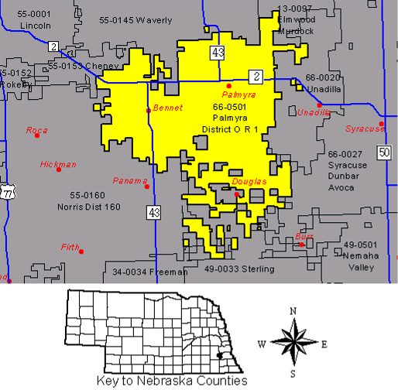

ENROLLMENT--LAST FRIDAY IN SEPTEMBER

 | K-6 | 7-12 | K-12 | K | 1 | 2 | 3 | 4 | 5 | 6 | 7 | 8 | 9 | 10 | 11 | 12
80-81 | 223 | 182 | 405 | 25 | 32 | 31 | 30 | 34 | 40 | 31 | 31 | 34 | 33 | 32 | 22 | 30
81-82 | 189 | 183 | 372 | 23 | 25 | 32 | 31 | 29 | 33 | 41 | 29 | 29 | 37 | 38 | 29 | 21
82-83 | 200 | 188 | 388 | 29 | 20 | 24 | 30 | 33 | 28 | 36 | 40 | 30 | 27 | 30 | 32 | 29
83-84 | 213 | 201 | 414 | 32 | 32 | 21 | 27 | 34 | 35 | 32 | 39 | 43 | 30 | 27 | 30 | 32
84-85 | 209 | 196 | 405 | 29 | 35 | 29 | 19 | 28 | 34 | 35 | 33 | 35 | 44 | 32 | 23 | 29
85-86 | 197 | 186 | 383 | 31 | 29 | 33 | 30 | 16 | 29 | 29 | 35 | 33 | 35 | 40 | 26 | 17
86-87 | 204 | 194 | 398 | 41 | 27 | 28 | 30 | 33 | 18 | 27 | 29 | 34 | 35 | 36 | 35 | 25
87-88 | 206 | 187 | 393 | 32 | 39 | 29 | 24 | 30 | 34 | 18 | 30 | 24 | 32 | 36 | 33 | 32
88-89 | 217 | 174 | 391 | 34 | 30 | 38 | 27 | 23 | 32 | 33 | 19 | 28 | 24 | 28 | 38 | 37
89-90 | 232 | 171 | 403 | 35 | 34 | 36 | 40 | 30 | 26 | 31 | 33 | 21 | 28 | 23 | 27 | 39
90-91 | 247 | 161 | 408 | 38 | 35 | 35 | 39 | 39 | 33 | 28 | 31 | 34 | 21 | 26 | 22 | 27
91-92 | 254 | 179 | 433 | 32 | 37 | 35 | 34 | 40 | 40 | 36 | 31 | 39 | 35 | 22 | 28 | 24
92-93 | 275 | 207 | 482 | 33 | 37 | 43 | 39 | 38 | 41 | 44 | 44 | 35 | 41 | 34 | 23 | 30
93-94 | 259 | 212 | 471 | 29 | 38 | 34 | 39 | 41 | 37 | 41 | 39 | 44 | 35 | 35 | 34 | 25
94-95 | 246 | 237 | 483 | 35 | 28 | 38 | 33 | 36 | 39 | 37 | 45 | 43 | 46 | 34 | 34 | 35
95-96 | 242 | 235 | 477 | 28 | 34 | 30 | 40 | 33 | 37 | 40 | 38 | 42 | 41 | 46 | 32 | 36
96-97 | 237 | 248 | 485 | 37 | 29 | 33 | 28 | 39 | 36 | 35 | 45 | 42 | 42 | 38 | 48 | 33
97-98 | 242 | 244 | 486 | 31 | 36 | 30 | 37 | 32 | 38 | 38 | 38 | 48 | 37 | 43 | 38 | 40
98-99 | 241 | 231 | 472 | 37 | 35 | 36 | 25 | 36 | 33 | 39 | 37 | 39 | 42 | 37 | 42 | 34
99-00 | 230 | 237 | 467 | 36 | 36 | 29 | 39 | 23 | 35 | 32 | 38 | 37 | 40 | 43 | 38 | 41
00-01 | 230 | 220 | 450 | 22 | 36 | 37 | 34 | 40 | 24 | 37 | 32 | 41 | 35 | 38 | 40 | 34
01-02 | 249 | 235 | 484 | 38 | 27 | 36 | 39 | 39 | 43 | 27 | 39 | 35 | 45 | 38 | 39 | 39
02-03 | 268 | 217 | 485 | 31 | 41 | 28 | 39 | 40 | 42 | 47 | 33 | 38 | 33 | 44 | 37 | 32
AVG | 231 | 205 | 436 | 32 | 33 | 32 | 33 | 33 | 34 | 35 | 35 | 36 | 36 | 35 | 33 | 31

ENROLLMENT PROJECTIONS

Statewide enrollment projections for public school districts in Nebraska indicate a peak enrollment in the 1997-98 school year with a steady decline anticipated for several years thereafter. District OR-1, on the other hand, is anticipating a modest, yet steady increase in enrollment during that same time period.

Student Dropout Rate

 | 1991-1992 | 1996-1997 | 2000-2001
State | 2.41% | 2.86% | 2.73%
OR-1 | 0.56% | 2.82% | 0.45%

Graduation Rate

 | 1996-1997 | 2000-2001 | 2001-2002
State | 93.46% | 93.61% | 92.57%
OR-1 | 103.03% | 100.00% | 100.00%

Free and Reduced Price Meals

 | 1996-1997 | 2000-2001 | 2001-2002
State | 28.57% | 30.46% | 31.23%
OR-1 | 17.53% | 18.67% | 20.25%

Mobility Rate

State 2001-2002 | 14.93%
OR-1 2001-2002 | 11.36%

STAFF

During the 2001-02 school year, District OR-1 Public Schools was served by a Superintendent, two Principals, an Assistant HS Principal/Activities Director, and a professional teaching staff of forty-three.

Average Teacher Salary

 | 1986-1987 | 1991-1992 | 1996-1997 | 2001-2002
State | $21,945 | $27,266 | $32,100 | $36,236
OR-1 | $19,879 | $22,910 | $29,778 | $33,135

Average Years of Teaching Experience

 | 1986-1987 | 1991-1992 | 1996-1997 | 2001-2002
State | 13.49 | 14.42 | 15.32 | 15.47
OR-1 | 14.21 | 12.78 | 15.71 | 14.24

Teachers with Master's Degrees

 | 1991-1992 | 1996-1997 | 2001-2002
State | 34.31% | 35.19% | 36.64%
OR-1 | 24.32% | 33.33% | 21.43%

High School Teachers Endorsed In Their Subject Areas
2001 - 2002
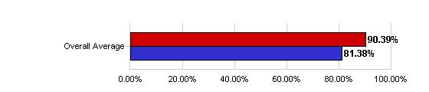
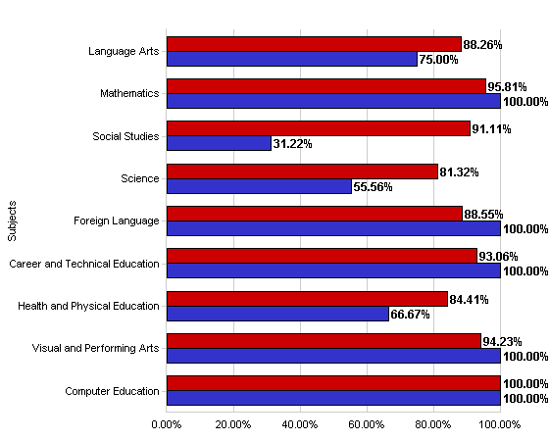

High School Teachers Endorsed In Their Subject Areas

Subjects | State Average | District Average
Language Arts | 88.26% | 75.00%
Mathematics | 95.81% | 100.00%
Social Studies | 91.11% | 31.22%
Science | 81.32% | 55.56%
Foreign Language | 88.55% | 100.00%
Career and Technical Education | 93.06% | 100.00%
Health and Physical Education | 84.41% | 66.67%
Visual and Performing Arts | 94.23% | 100.00%
Computer Education | 100.00% | 100.00%
Overall Average | 90.39% | 81.38%

FINANCIAL DATA

DISTRICT VALUATION

District OR-1 property valuations have shown a significant increase over a period of time. The following graph and chart display those changes over a period of ten years.

Despite the trend of increasing valuation, it remains difficult to predict annual growth in valuations as indicated on the following chart.

TAX LEVIES

Total tax levy rates have primarily declined over the last few years. The total levy for the 2001-02 school year was the lowest total levy in the known history of the school district.

STATE AID

State aid continues to be difficult to predict. The graph and chart below display state aid over the last thirteen years.

District OR-1 2000 - 2001 Receipts

 | Receipts | Percent
Local | $2,074,695.59 | 68.74%
County | $26,767.52 | 0.89%
State | $881,870.87 | 29.22%
Federal | $27,065.09 | 0.90%
Other | $7,816.22 | 0.26%
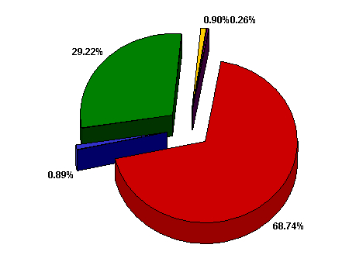

All Nebraska School Districts 2000 - 2001 Receipts

 | Receipts | Percent
Local | $1,008,362,310.88 | 52.44%
County | $17,560,195.80 | 0.91%
State | $776,425,813.39 | 40.38%
Federal | $104,520,984.75 | 5.44%
Other | $15,945,906.99 | 0.83%

District OR-1 2000 - 2001 Expenditures

 | Expenditures | Percent
All Instruction | $1,977,863.88 | 63.22%
Support Services - Pupils | $223,137.06 | 7.13%
Support Services - Staff | $115,070.22 | 3.68%
Central Administration | $190,799.03 | 6.10%
Office of the Principal | $241,318.81 | 7.71%
Maintenance & Operation | $300,957.46 | 9.62%
Federal | $33,033.04 | 1.06%
Other | $46,351.68 | 1.48%

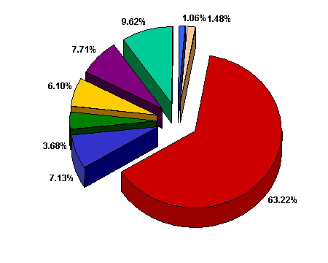

Expenditures
State Average and District Comparison
2000 - 2001 School Year
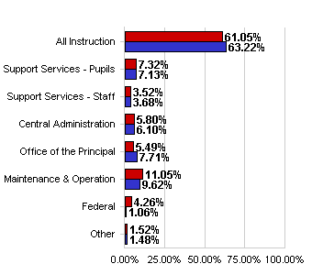
  2000 - 2001 Comparison
   | State Average | District
  All Instruction | 61.05% | 63.22%
  Support Services - Pupils | 7.32% | 7.13%
  Support Services - Staff | 3.52% | 3.68%
  Central Administration | 5.80% | 6.10%
  Office of the Principal | 5.49% | 7.71%
  Maintenance & Operation | 11.05% | 9.62%
  Federal | 4.26% | 1.06%
  Other | 1.52% | 1.48%

School Improvement

District OR-1 first committed to the School Improvement Process (SIP) in the fall of 1993. At that time, a significant number of interested persons from the community, staff, and board of education began the process by developing a mission statement for the district. The mission statement and belief statements that were developed are as follows:

“Together, we prepare our students to successfully meet the challenges of the future”

District OR-1 will:

- Model and reinforce a sense of self-respect and respect for others.
- Provide equal opportunity for each student to develop his/her potential.
- Seek to develop a sense of individual responsibility and integrity.
- Seek and integrate educationally sound innovations into the curriculum.
- Provide a safe learning environment.

In the years that followed, a number of objectives were identified and the resources of the district were brought to bear on those challenges. Early areas of concern tended to spotlight the shortcomings associated with facilities and learning tools. With the completion of the building additions and renovations in 1998, efforts to improve curricular areas to meet the needs of all students became the focal point.

The process is now at the end of the second five-year cycle and gearing up to begin a third five-year cycle. The following individuals have been appointed by the board of education to provide the leadership necessary for this endeavor. The steering committee members are:

David Bottrell Co-Chairman
Steve Robb Co-Chairman
Ken Malone Secondary Staff
Jean Cheney Elementary Staff
Britanny Lang Student
Erik White Student
Jill Weatherly Special Education
Todd Calfee Parent
Jaimi Calfee Parent
TBA Board of Education
Clyde Childers Ex-officio Member

In addition, the committee will be assisted by Margaret McInteer and Mitzi Hoback of ESU #4 as the process continues.

To date, the steering committee has met twice, once in mid November and the second time in mid December. It has been concluded by the committee that the mission statement and belief statements created by the original committee continue to express the interests of the stakeholders of District OR-1.

As the process continues, the steering committee will be soliciting the help and involvement in the process from additional members of the school community. The committee’s goal is to gather and analyze data related to student learning by spring of the 2002-03 school year. It is further intended that by the fall of 2003, a data driven selection of a goal for improvement of student learning will be identified and that an action plan for addressing that goal will be developed during the 2003-04 school year.

